

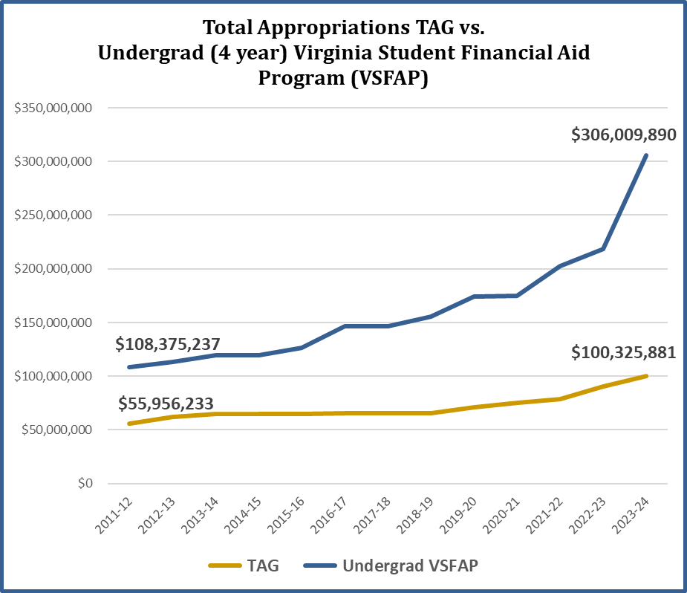

Contacts with CICV:
Robert Lambeth Sabena Moretz
President Director of Government Relations & Member Services
lambeth@cicv.org sabena@cicv.org
434-941-0869 804-380-5675

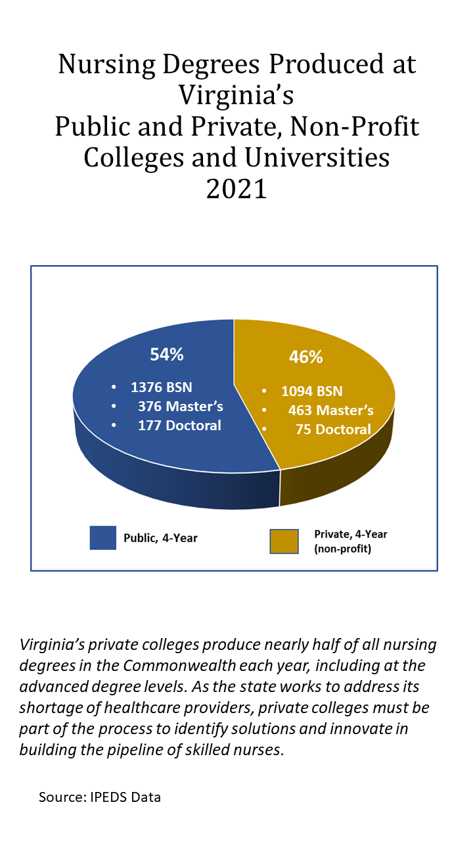

https://law.lis.virginia.gov/vacode/title23.1/chapter1/section23.1-105/

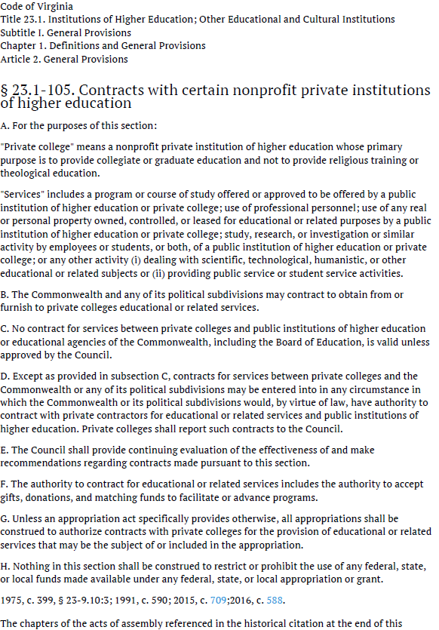


https://law.lis.virginia.gov/constitution/article8/section11/

